Chemistry Honors Sparknotes

# Elements

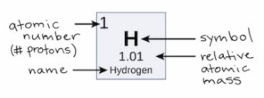

## Weighted Average

Percent worth of 100% × amount for section

Percent worth of 100% × amount for section

* Percent worth of 100% × amount for section

------------------------------------------------------------------

## Basic Atomic Structure

The 3 Subatomic Particles of an atom:

* Proton(Positive Charge)
  + Found in the nucleus
  + Weighs 1 AMU(Atomic Mass Unit)
  + Gives Element its Atomic Number
* Neutron(Neutral Charge)
  + Found in the nucleus
  + Weighs 1 AMU
  + Contributes to the elements atomic mass
* Electron(Negative Charge)
  + Found in the cloud or shell
  + Does NOT contribute to elements atomic mass(1/1840 amu)

## Isotopes

* Two atoms of the same element with different masses
  + Due to the amount of neutrons in an atom
  + Ex:
    - Carbon - 12
    - Carbon - 14

## Ions

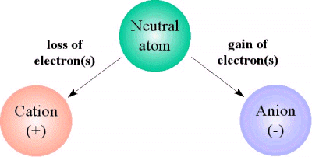

* Right side of the periodic table contains the Cations
  + Loses an electron
  + Mostly the metals
* Left side of the periodic table contains the Anions
  + Gains electron(s) to fill or create a more stable element
  + Mostly nonmetals
* Cations donate electrons to anions
* Every element wants 8 valence electrons

|  |  |  |  |
| --- | --- | --- | --- |
| Column Number | Charge | # electrons lost/gained | # of valence electrons |
| 1 | 1+ | 1 e lost | 1 |
| 2 | 2+ | 2 e lost | 2 |
| 13 | 3+ | 3 e lost | 3 |
| 15 | 3- | 3 e gained | 5 |
| 16 | 2- | 2 e gained | 6 |
| 17 | 1- | 1 e gained | 7 |

* Naming Ions
  + Cations: Go by their element name and add ion at the end
    - Ex. → Calcium Ion
  + Anions: Add “-ide:” to their ending
    - Ex. → Nitride Ion

## Spectroscopy

* Electron particles get excited and “jump” to different energy levels
  + When these particles jump or fall they give off energy in the form of light
* Every element has its unique spectrum

## Quantum Mechanics and Probability

* A Particle can be anywhere until you look and out where it is
* The energy of electrons is quantized meaning only certain energies are allowed for different types of electrons.
* Electrons behave like particles and waves

## Quantum Models and Atoms

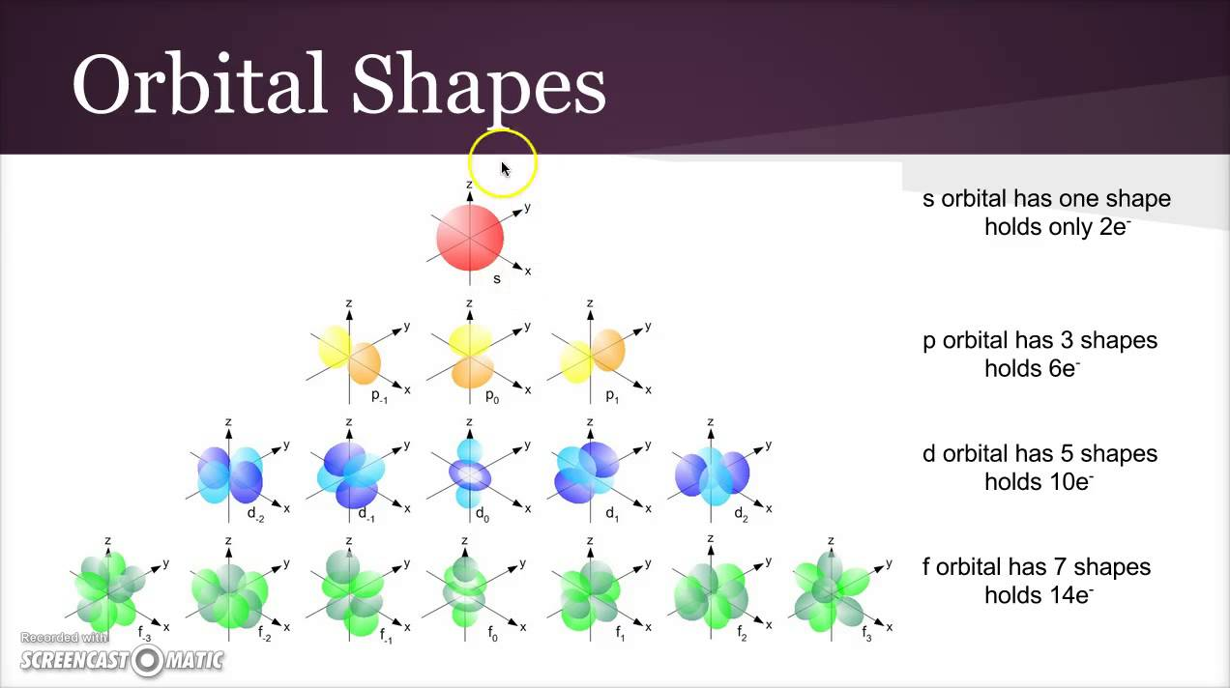

1s

2s, 2p

3s, 3p, 3d

4s, 4p, 4d, 4f

5s, 5p, 5d, 5f

6s, 6p, 6d

7s, 7p

* The number in front of the character is the Principal quantum number
  + Principle quantum number tells you the amount of sub-levels
* The character represents the orbital respectively:
  + S orbital can hold 2 electrons
    - Looks like a sphere
  + P orbital can hold 6 electrons
    - Looks like a figure 8 rotated around an axis
  + D orbital can hold 10 electrons
    - Looks like a clover rotated on two seperate axis
  + F orbital can hold 12 electrons
    - Two d-orbitals on top of one another
* **Aufbau Principle**
  + Electrons look for the lowest energy to fill first.
* **Pauli Exclusion Principle**

1. Only 2 electrons can occupy one orbital
2. In order to occupy the same orbital, electrons must have opposite spins

* **Hund’s Rule**
  + Electrons will fill each orbital with one electron, with the same spin, before doubling up in the same orbital.

# Models

## Bohr’s Model

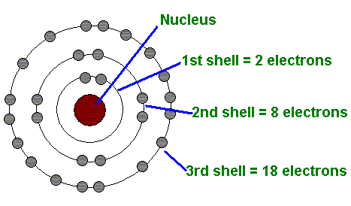

* Center is the Nucleus containing Protons and Neutrons
* Electrons are surrounding the Nucleus
* To calculate the amount of electrons per level is 2
* Used to predict reactivity
  + Look at valence electrons

## Lewis Dot Structures

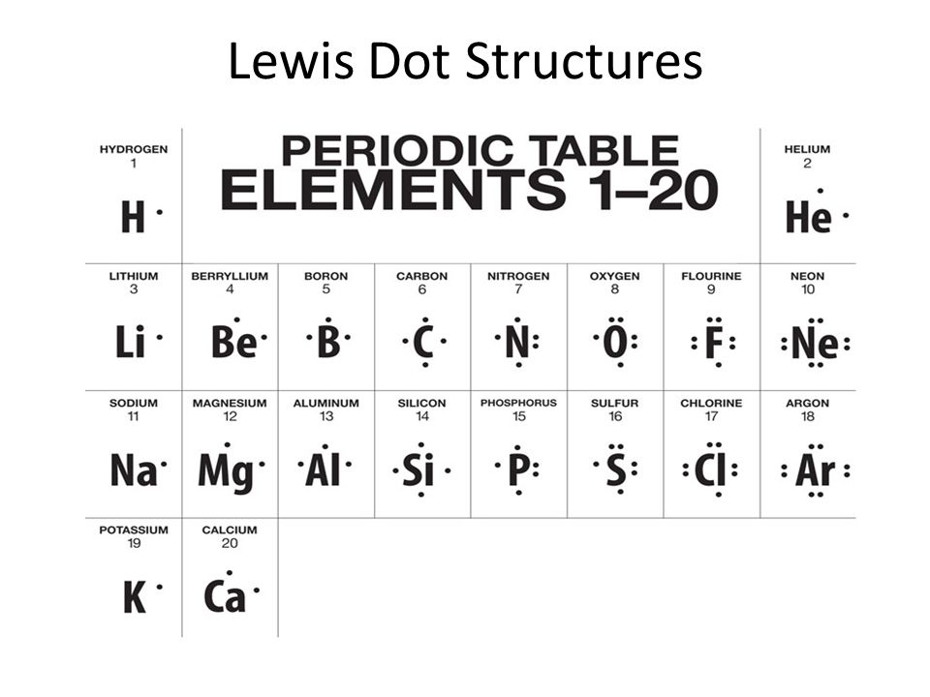

# The Periodic Table

## [Periodic Table](https://www.ptable.com/)

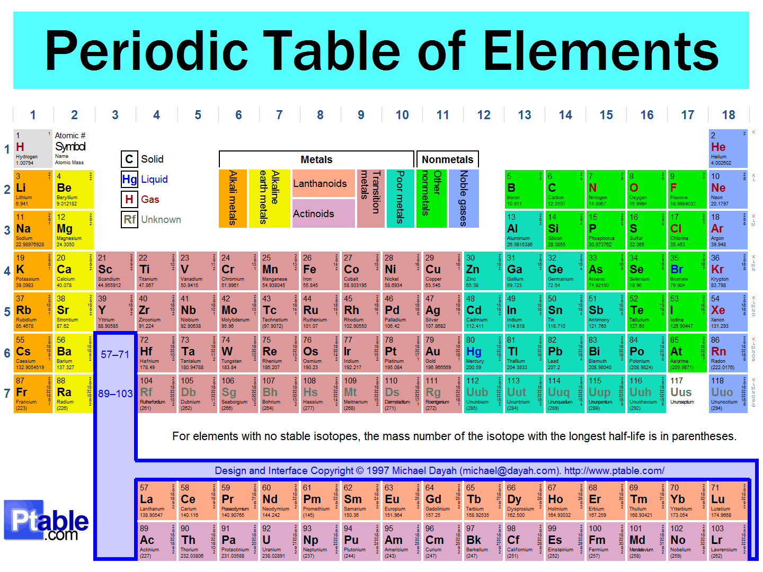

* **Rows and Columns**
  + Columns are called Groups
    - 18 of them
    - Have similar chemical properties due to their similar electron configuration
  + Rows are called periods
    - 7 of them
  + 118 Elements in total
* **Groups in the Periodic Table**
  + Akali Metals
    - Far left Column
    - Highly reactive with only one valence electron
  + Halogens
    - Column 17 on the periodic table
    - Highly corrosive non-metals that have 7 valence electrons
  + Noble Gases
    - Far right Column
    - Have a complete Valence Electron shell of 8 electrons
    - Do not react with other elements
  + Transition Metals
    - The elements in the d block.
    - Inner transition metals are the f block(Lanthanoids and Actinoids)
* **Type of Elements**
  + As you move left to right on the periodic table properties of elements become less metallic and more non-metallic.
    - Metals - comprises 80% of all elements
    - Metalloids - part metal, part non metal. Only 7 Elements:
      * B, Si, Ge, As, Sd, Te, Po
    - Non-Metals - on right side of periodic table
* **Properties of Metals**
  + Luster
  + Good COnductors
  + Malleable
  + Ductile
  + Solid at room temp.
    - Exception is Hg(Mercury)
* **Properties of Non-Metals**
  + Not Shiny
  + Do NOT conduct heat or electricity
  + Brittle
  + Mostly gases, but some are solid at room temp, one is a liquid.
    - Liquid is bromine

## Periodic Trends

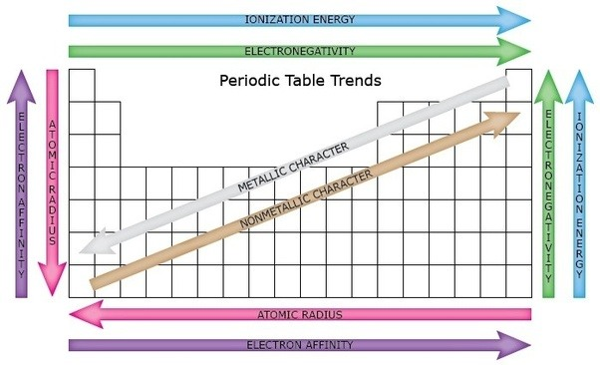

* **Atomic Size**
* Calculated by the distance between two nuclei of the same element in half
  + Largest was Francium smallest was Helium
  + Decreased from left to right across Periods
  + Increased from lowest to highest energy levels in columns
* **Electronegativity**
* The ability of an atom to attract an electron or electrons when in a compound
  + Noble gases are not included because Electronegativity focuses on the ability to gain an electron and Noble gases have a full valence shell
  + Most Electronegative element was Fluorine; the least was Francium
  + Increased from left to right across Periods
  + Increased from highest to lowest energy level in columns
* **Ionization Energy Trend**
* The energy required to remove an electron from an atom
  + Increase from left to right across a Period
  + Decrease from top to bottom
  + Shielding - Inner electrons at lower energy levels essentially block the proton’s force of attraction toward the nucleus
* **Electron Affinity**
* The energy given off when a neutral atom in the gas phase gains an extra electron to form a negatively charged ion
  + Decrease from top to bottom
  + Increase from left to right across a period.

# Bonding

### Octet Rule

* + Atoms prefer to have **eight valence electrons** (or a completely full valence shell)

## Ionic Bonding

* Composed of Cations and Anions(Ions)
* Strongest Bond
* Mostly Bonds between Metals and Non-Metals
* When dissolved in water, the ions *dissociate*(pull apart)
  + Ionic Solutions(dissolved ionic compounds)
    - Will conduct electricity in water
* Exchanges electrons
* Make crystal lattice structures
  + Which causes:
    - High melting points
    - High boiling points
* Always represented by empirical formula
* Ex. Ammonium Bicarbonate

## Covalent Bonding

* Weakest Bond of all others
* Forms molecules
* Do not dissociate in water
  + Does not conduct electricity
* Bonds represented by Dashes
* Takes place between two nonmetals
* Sharing electrons between atoms
* Single(σ), double(π), and triple(has both) bonds

## Diatomic Elements

* Br, I, N, Cl, H, O, and F
  + Always found as pairs in nature; form molecules

## How to Differentiate Between Bonds

1. Calculate the difference in electronegativity
2. Use the table to define which type of bonding it is

|  |  |  |  |
| --- | --- | --- | --- |
| Types  Of  Bonds | Ionic | Covalent | |
| Polar | Non-Polar |
| Difference in Electronegativity |  |  |  |

`

## Polar vs. Non-Polar Bonding

* Determined by an element's electronegativity

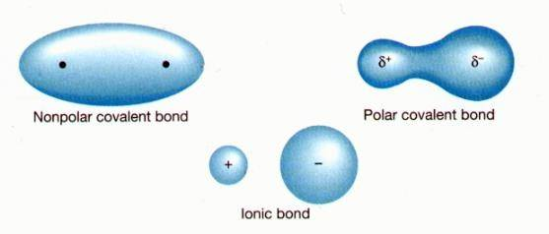

* **Non-Polar Bonds**
  + Bond between identical non-metal elements
  + Difference in electronegativity: 0 to 0.4
  + Examples: O₂, H₂, H₂S
  + Shared pair of electrons is pulled equally by the positive nuclei of the atom
* **Polar Bonds**
  + Covalent bonds that do not share the electron pair equally
  + Example: HCl
  + The more electronegative elements the electrons more strongly so electrons spend more time around the element
  + Electronegative elements becomes slightly negative
  + Difference in electronegativity: 0.4-2.0

## IMF(Intermolecular Force)

* **London Dispersion Forces**
  + Definition
    - Attraction between 2 instantaneous dipoles
    - Asymmetrical electron distribution
    - All atoms and molecules
  + Relative Strength
    - Weakest
  + Increase in strength as molar mass increases(more electrons).
* **Dipole-Dipole Forces**
  + Definition
    - Attraction between 2 permanent dipoles
    - Polar molecules
  + Relative Strength
    - Medium Strength
  + Stronger when molecules are closer together
* **Hydrogen Bonding**
  + Definition
    - Attraction between molecules with N-H, O-H, & F-H bonds
    - Extremely polar bonds ⇒ very strong dipole-dipole force
  + Relative Strength
    - Strongest
  + ***Not*** chemical bonding

## VSEPR Theory

* VSEPR: Valence Shell Electron Pair Repulsion
* The repulsion between electron pairs causes electron pairs stay as far apart as possible.

## Polyatomic Ions

* Polyatomic Ions are charged groups of nonmetal atoms held together with covalent bonds
  + Form an Ionic bond
  + Acts just like a single atom would

|  |  |  |  |
| --- | --- | --- | --- |
| [C₂H₃O₂]¹⁻ | Acetate | [OH]¹⁻ | Hydroxide |
| [NH₄]¹⁺ | Ammonium | [ClO]¹⁻ | Hypochlorite |
| [CO₃]²⁻ | Carbonate | [NO₃]¹⁻ | Nitrate |
| [ClO₃]¹⁻ | Chlorate | [NO₂]¹⁻ | Nitrite |
| [ClO₂]¹⁻ | Chlorite | [C₂O₄]²⁻ | Oxalate |
| [CrO₄]²⁻ | Chromate | [ClO₄]¹⁻ | Perchlorate |
| [CN]¹⁻ | Cyanide | [MnO₄]¹⁻ | Permanganate |
| [Cr₂O₇]²⁻ | Dichromate | [PO₄]³⁻ | Phosphate |
| [HCO₃]¹⁻ | Bicarbonate | [SO₄]²⁻ | Sulfate |
| [HSO₄]¹⁻ | Bisulfate | [SO₃]²⁻ | Sulfite |
| [HSO₃]¹⁻ | Bisulfite |  |  |

* **Formulas for Ionic Compounds**

1. Cation(+) 1st, Anion (-) 2nd
2. Identify valence for each
3. Identify the charge of atom
4. Criss-Cross rule

* **Names for Ionic Compounds**

1. Cation(+) 1st, Anion (-) 2nd
2. Anion ends in -ide if element

Ex. NaCl = Sodium Chloride

* When there is more than one polyatomic ion in a compound, brackets or parentheses must be placed around it.

# Formulas

## 1.Empirical Formula

* Gives the lowest whole-number ratio of atoms in covalent compound
  + Ex. C₂H₂ (acetylene) ; C₈H₈ (Styrene)
* These molecules have the same empirical formula(CH) bu different molecular formulas

## 2.Molecular(Chemical) Formula

* Shows how many atoms of each element a molecule contains
  + Does not tell the structure of the molecule
  + Ex. CO₂ ; H₂O ; O₆C₁₂O₆

## 3. Structural Formula

* Represents bonds by dashes and shows arrangement of atoms
  + Examples:

Methane(CH₄) Ethane(C₂H₆)

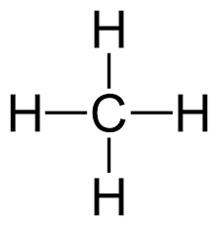 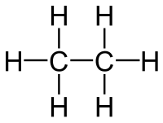

* **Chemical vs. Structural Formulas**
  + Chemical formula: C₂H₆O
  + Structural formula:

Ethanol Dimethyl Ether

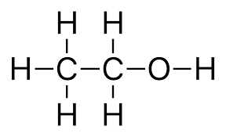 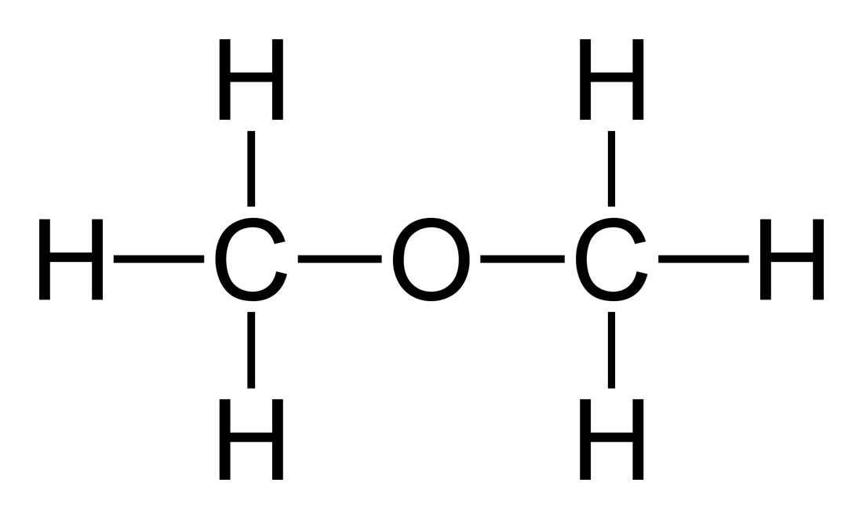

#### **Isomers:**

* + - Same molecular formula but different structural formula

# Five Types of Reactions

## 1. Synthesis Reactions

* (Single compound is formed from two or more elements)
* General formula is
* Examples:
  + C + O₂ → CO₂
  + CaO + H₂O → Ca(OH)₂

## 2.Decomposition Reaction

* A single compound is broken down into two or more simpler compounds
* Opposite of a Synthesis Reaction
* General form is
* Examples:
  + C₁₂H₂₂O₁₁ → C + H₂O
  + Ag₂O → Ag + O₂

## 3.Combustion Reaction

* Hydrocarbon + Oxygen → Carbon Dioxide + Water
* Follow a set of special rules to balance combustion reactions
* Examples:
  + C₃H₈ + O₂ → CO₂ + H₂O
  + CH₃CH₂OH + O₂ → CO₂ + H₂O

## 4.Single Displacement Reaction

* A neutral element becomes an ion and replaces another ion in a compound
* General Formula is ***OR***

*Positive Ion replaced* *Negative Ion Replaced*

* Examples:
  + Zn + H₂SO₄ → ZnSO₄ + H₂
  + CL₂ +KBr → KCL + Br₂

## 5.Double Displacement Reaction

* Two aqueous compounds exchange ions and form two new compounds
* General form is
* Examples:
  + HCl + NaOH → H₂O + NaCl
  + AgNO₃ + NaCl → AgCl + NaNO₃

# Naming Compounds

1. A prefix in the name of a binary molecular compound tells how many atoms of an element are present in each molecule
2. Listed in same order as formula. Omit “mono” for first element.
3. Suffix of “ide” for second element.

* Cross out the first vowel if a in a compound name:
  + OO
  + OA
  + AO
* Prefix for Binary Molecules:

1. Mono-
2. Di-
3. Tri
4. Tetra-
5. Penta-
6. Hexa-
7. Hepta-
8. Octa-
9. Nona-
10. Deca-

# Acids and Bases

## Acids

* A solution that has an excess of H⁺ ions.
  + Latin acidus means sharp/sour
* The more H⁺ ions, the more acidic the solution
* **Properties**
  + Tastes Sour
  + Conduct Electricity
  + Corrosive
  + Many acids react strongly with metals to make H₂ gas
  + Turns blue litmus paper red
* HCl + Mn → H₂ + MnCl₂
* H[Acidic base] + metal → H₂ + [New Compound]
* Acetic acid ~ Vinegar
* Citric acid ~ Citrus fruit and sour candies
* Ascorbic acid ~ Vitamin c
* Sulfuric acid is used in car batteries (lead-acid)
* **pH Scale**
  + How acidic a solution is
  + Scale from 0 to 14
  + Below 7 = Acidic
  + 0 = Very Scidic
  + 7 = Neutral
    - Pure water
* A charge of 1pH unit represents tenfold(x10) change in the acidity of the solution
* **Arrhenius Definition(Traditional)**
  + Acid that produces H⁺ ions (or hydronium ions H₃O+)
* **Brønsted-Lowry**
  + Acid is a proton(h) donor
  + A “proton” is really just a hydrogen atom that has lost its electron

## Bases

* A base is a solution that has an excess of OH- ions.
* Another word for base is alkali.
* Bases are substances that can accept hydrogen ions
* **Properties**
  + Slippery
  + Taste Bitter
  + Corrosive
  + Can Conduct Electricity
  + Do not react with metals
  + Turns red litmus paper blue
* Examples:
* Cleaner
* Chalk
* Blood
* **Arrhenius Definition(Traditional)**
  + Produce OH- ions
  + (Problem: some bases don’t have hydroxide ions)
* **Brønsted-Lowry**
  + Proton Acceptors

## Lewis Acids/Bases

* **Acid**
  + Electron pair acceptor
* **Bases**
  + Electron pair donor